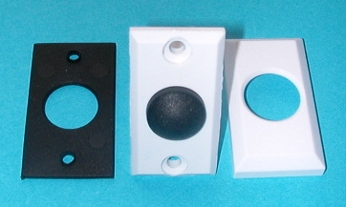
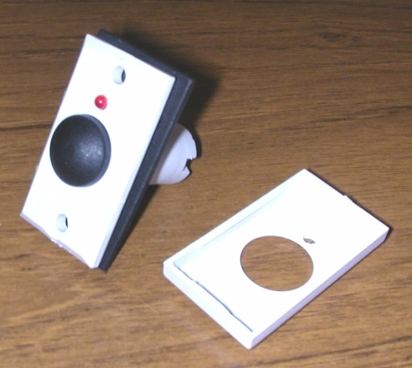
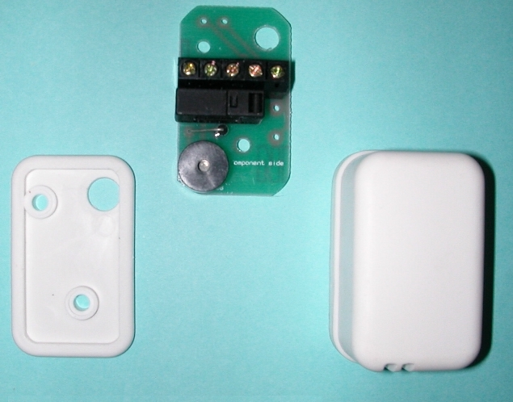
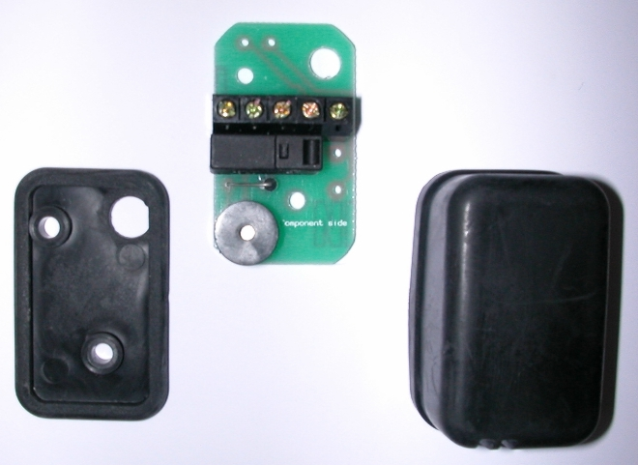

ModelZ01Z02Z20Z20BGrade 2 Class III●●--Grade 3 Class III--●●●Weatherproof casing●●●●Sealed Reed Switch●●--ABS Body●●--EVA Diaphragm●●--Fitted Resistor-●--Ind. Terminals-●--LED Green-●--LED Red-●--Sound Pressure 90DBA/30cm●●--Z01-Z02LengthWidthHeightDimensions Fascia45256mmDimensions Body45 2715.5mmMicro-Switch--●●Tampered----Flush Mounted●●--Surface Mounted--●●Concealed Fixings--●●Z20-Z20BLengthWidthHeightDimensions543521mm
© Knight Fire & Security Products Ltd
All cases of ™ Infringement will be pursued.
Description:
Grade 2 & 3 Class III
Final Exit Set Switch

Materials:
Body and Cover Plate - ABS
Diaphragm - EVA

Temperature Range:
-40ºC to +125ºC

Reed:
Sealed Magnetic Reed Switch

Switching Current
500mA Max DC

Voltage Range:
200v DC Max

Colours:
ZO1 – ZO2 – White
Z20 – White, Z20B - Black

Fittings:
Wire Clamping Terminals
Concealed Fixing Screws
Fig. 3 – Z20 Final Exit Set Switch
Unit 84 Seawall Road Ind. Estate
Cardiff UK CF24 5TH
Tel:0 (00 44) 29 20 48 81 29
Fax:0 (00 44) 29 20 48 91 32
Knight
Fire & Security Products Ltd
mailto:info@knightfireandsecurity.com
Drawing No:ZO1-Z20 Final
Exit Switches
Drawn:Chris Moorman
Date:04/09/09
All dimensions in mm
Do not scale
Fig. 1 - Z01 Flush Final Exit Set Switch
Fig. 2 - Z02 Flush Final Exit Set Switch
Fig. 4 – Z20B Final Exit Set Switch

